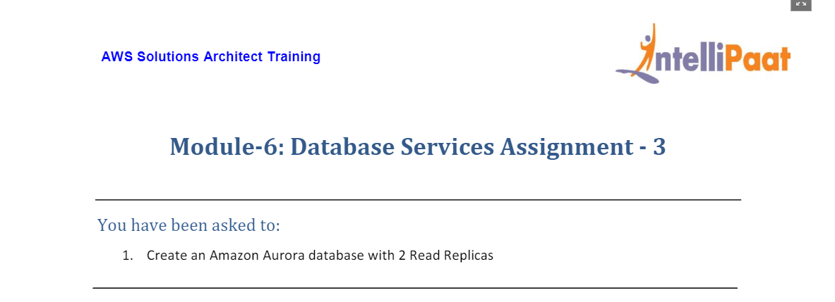

1. Choose RDS Service on AWS Console

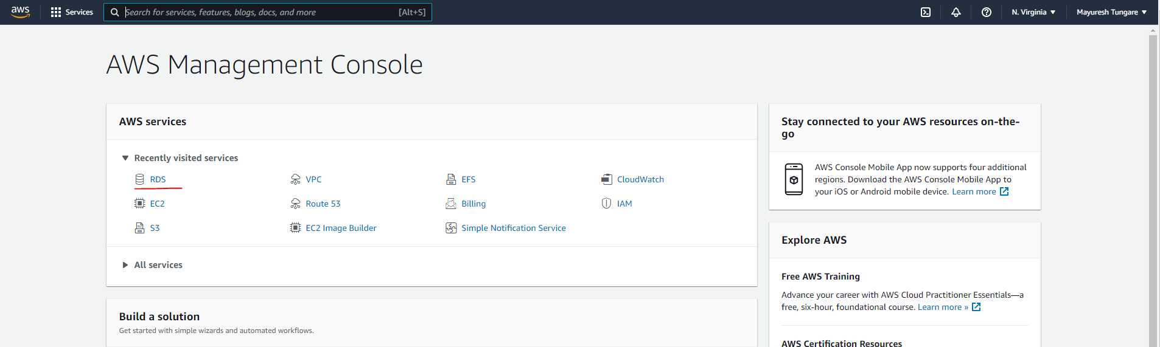

1. Choose Create Database option

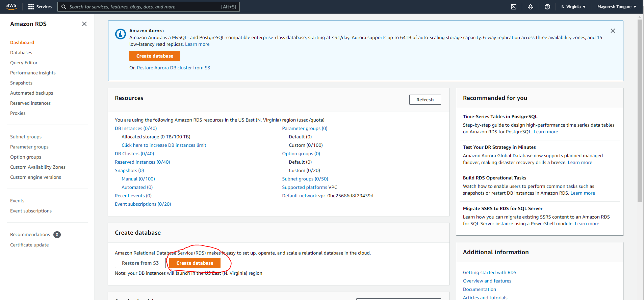

1. Choose the following options – Standard template.

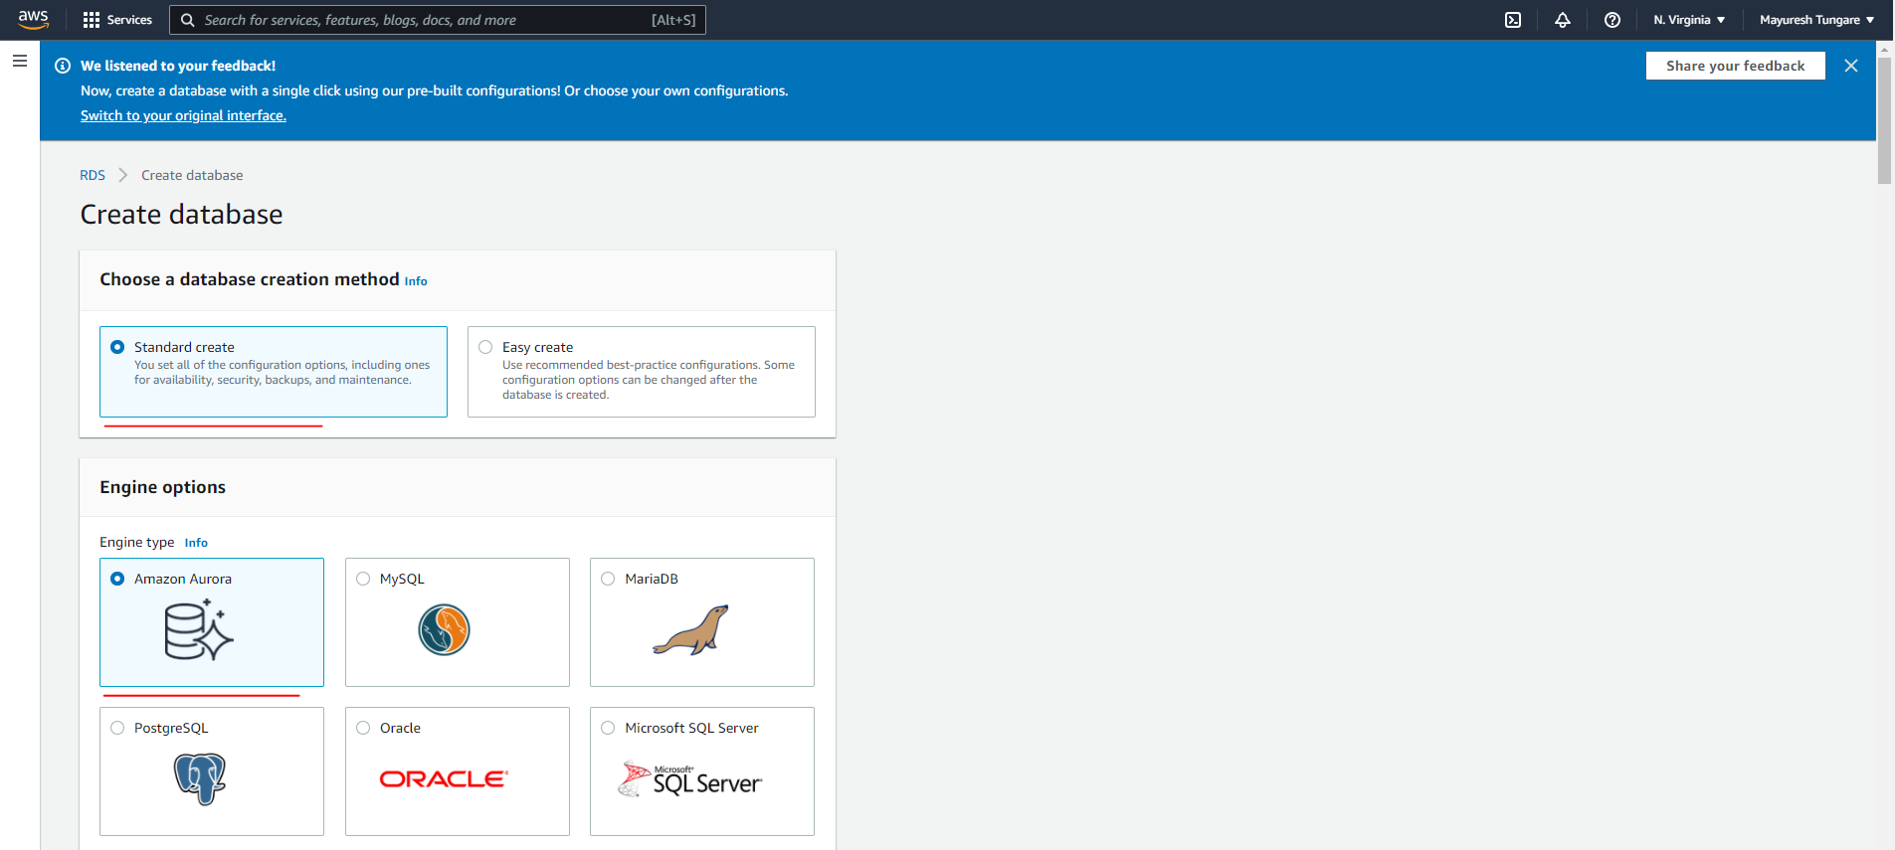

1. Next you can choose the edition (MySQL compatible), Provisioned as capacity type, the appropriate instance type, choose dev/test as the template.

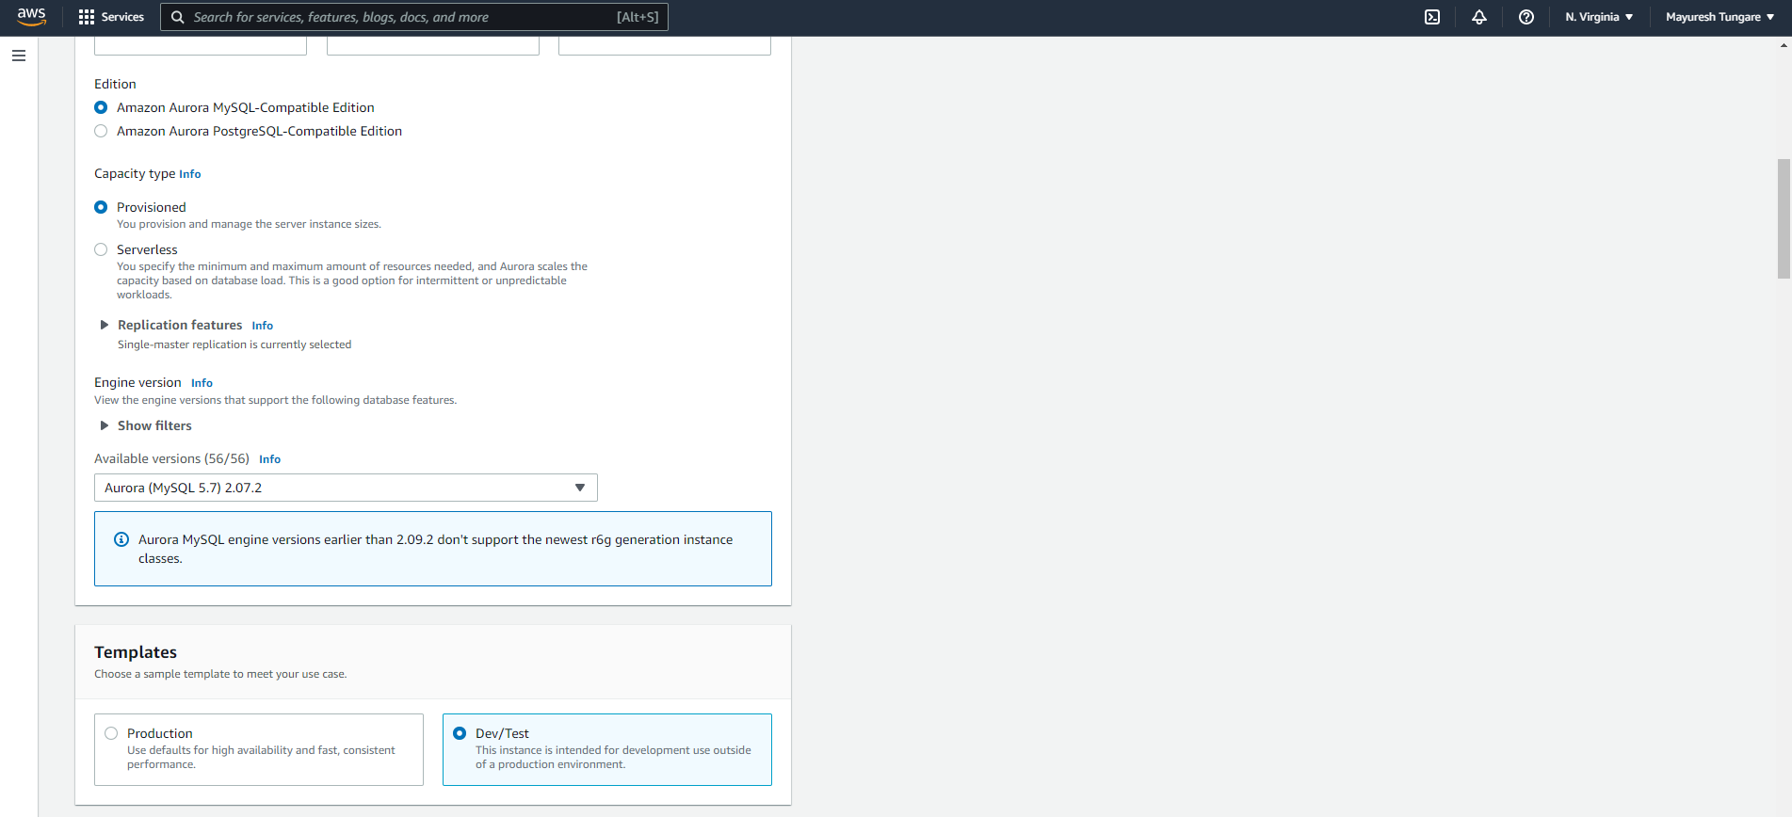

1. Provide a name for the DB cluster, provide credentials (username and password) and choose a DB instance class.

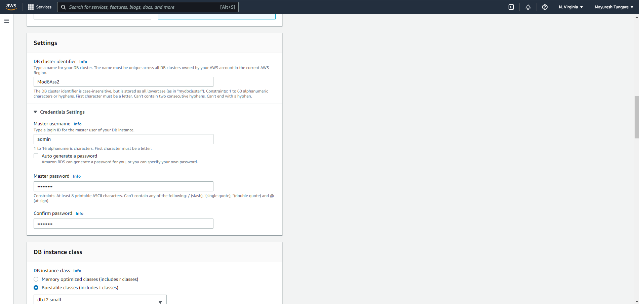

1. Choose Multi-AZ deployment, VPC and subnet creation/ configuration. Also ensure you enable public access (for the purpose of this assignment).

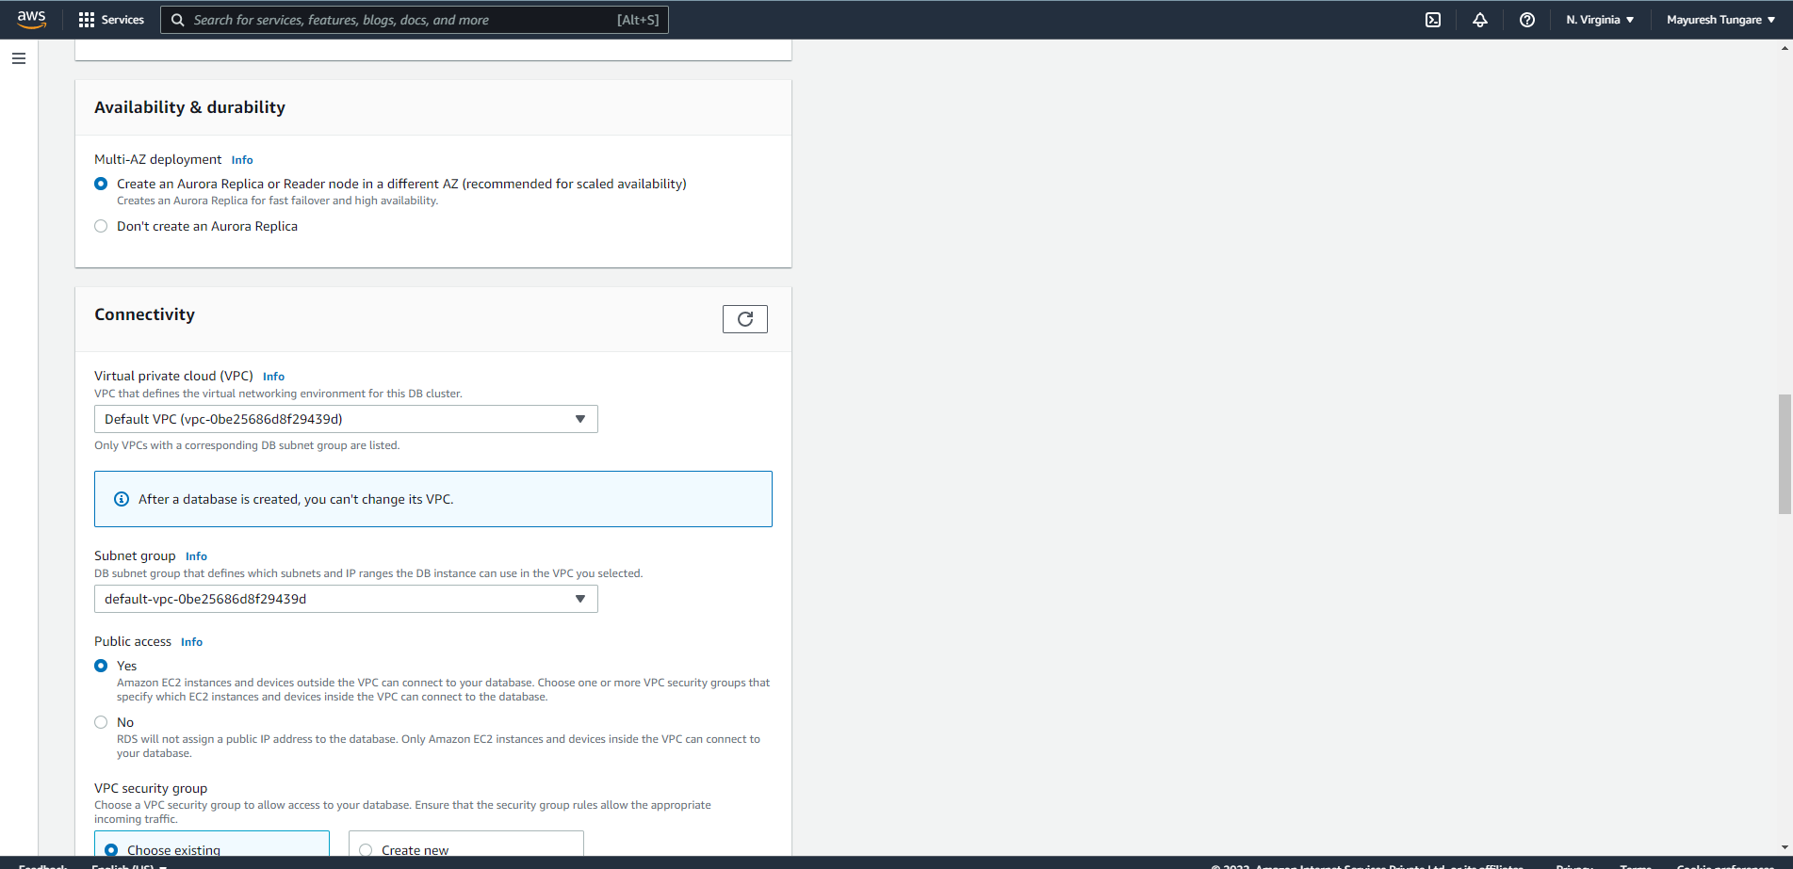

1. In additional configuration, provide DB name, cluster and parameter group name, failover priority, select backup retention days, enable encryption

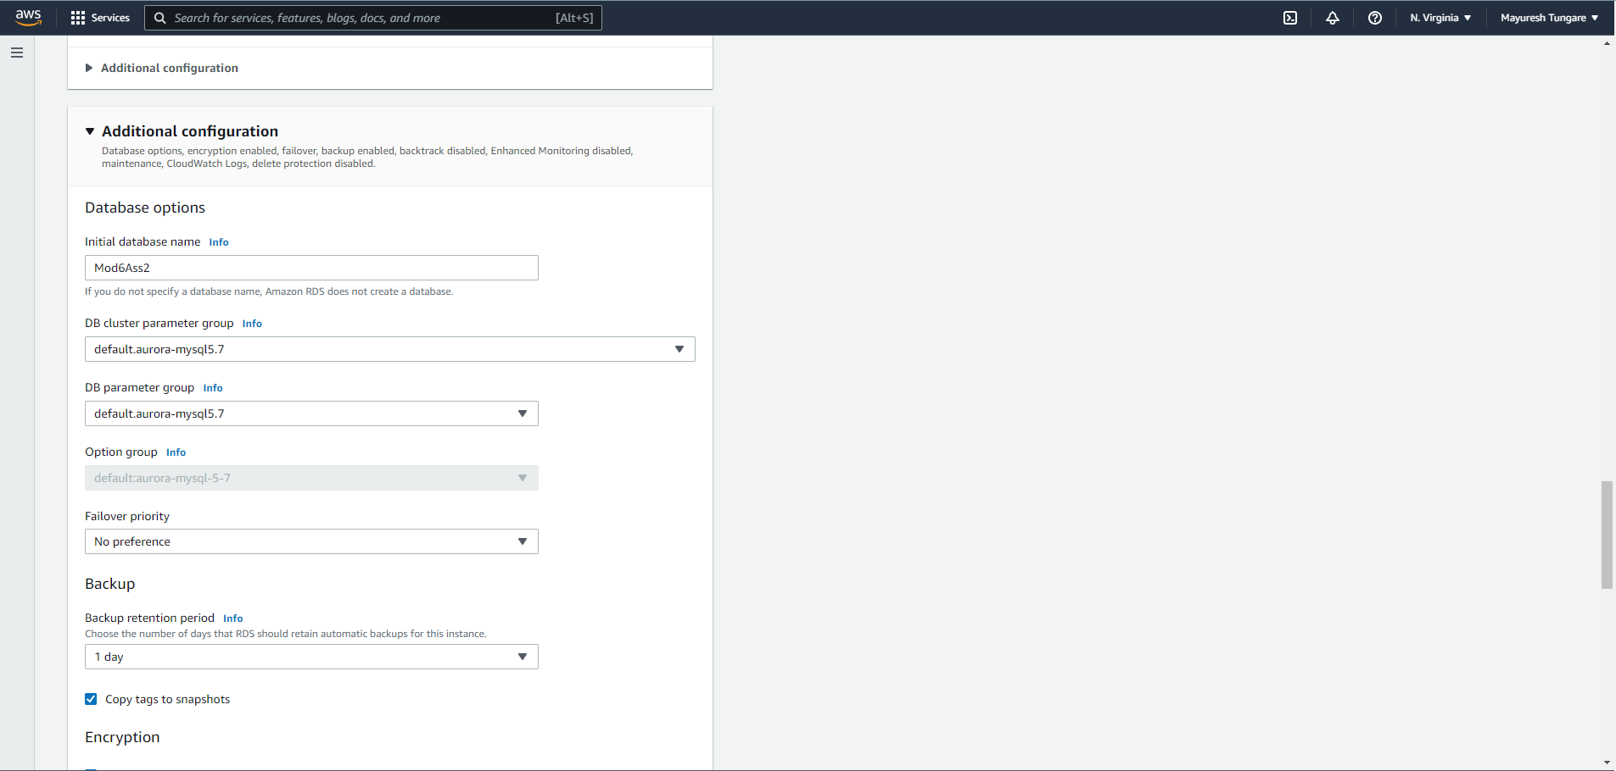

1. After all information is provided, click on create database.

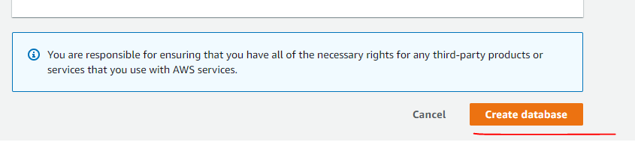

1. After that DB will created. Note DB creation takes time (atleast 5-7 minutes). You will note that by default a replica is created in another AZ (based on the option we selected while creating).

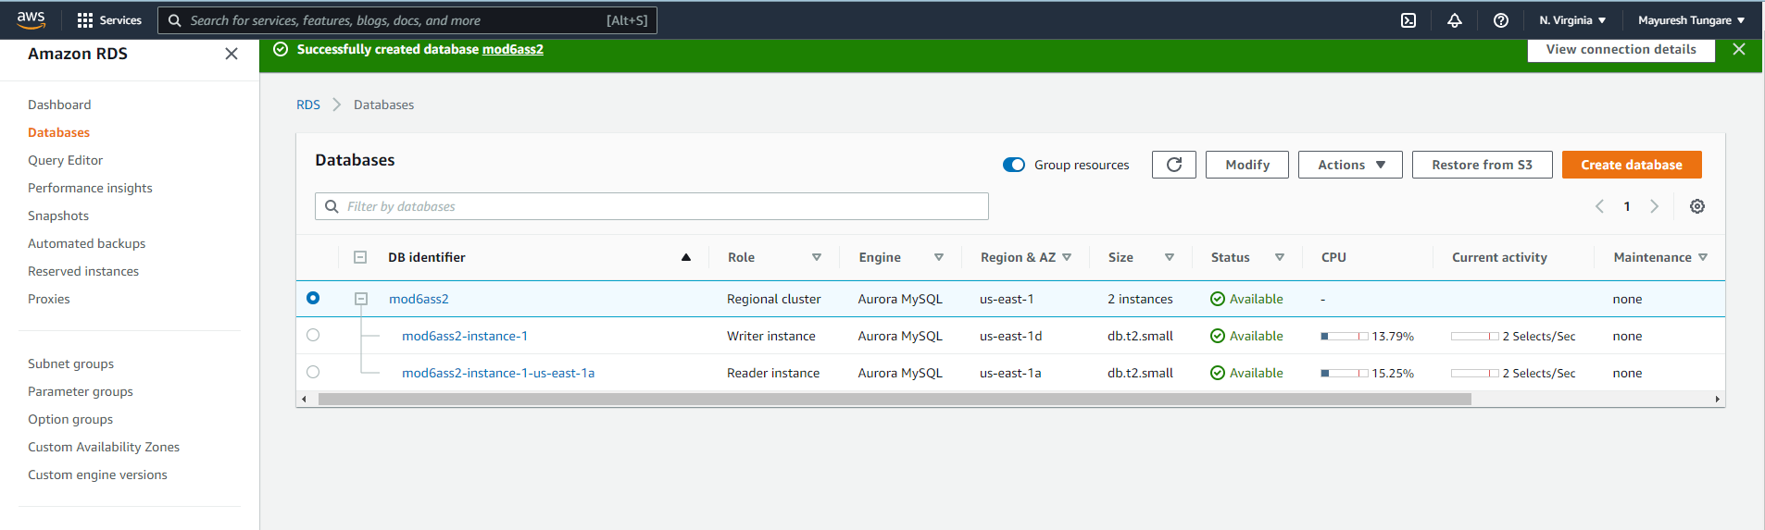

1. For creating another replica, you can go to Action and click on ‘Add reader’. Add information such as instance identifier, select the region, instance class, connectivity etc.

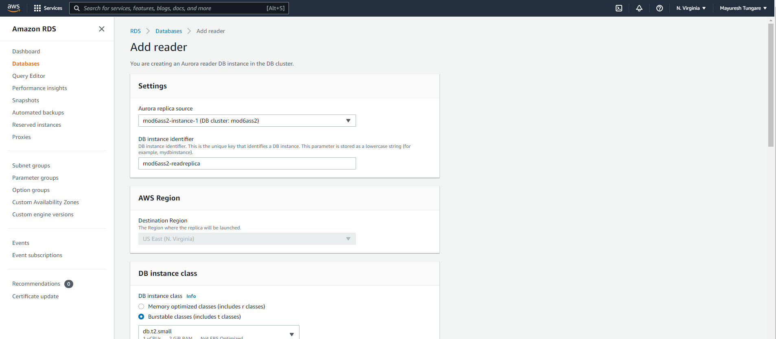

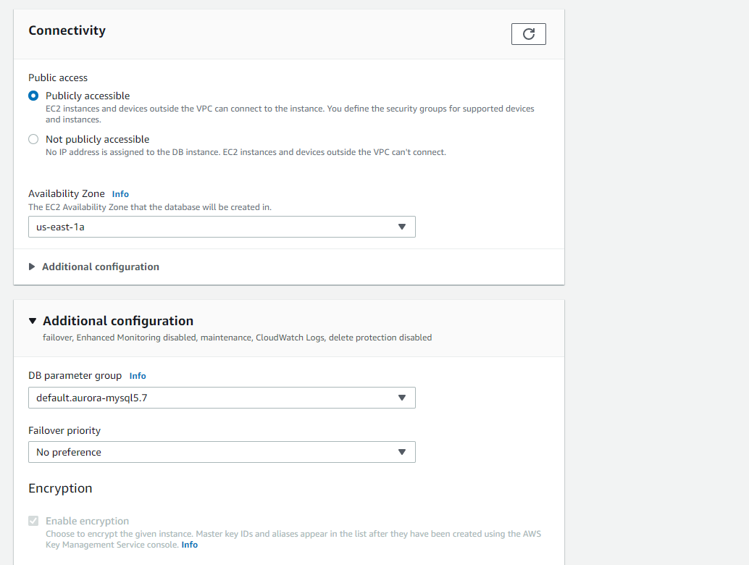

1. After you have entered all the details, click on ‘Add Reader’.

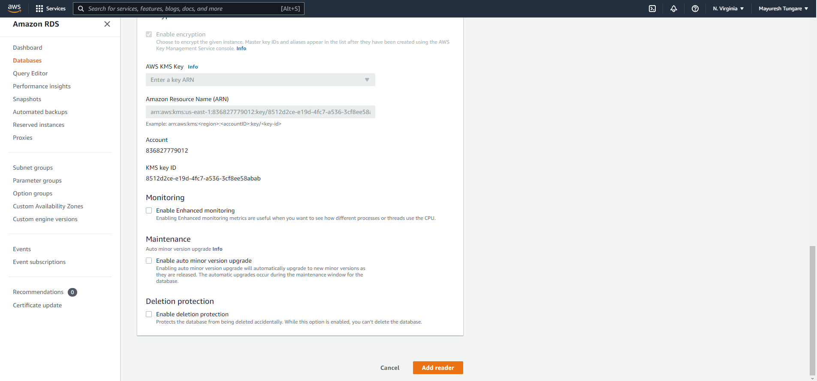

1. After you click on Add reader, you will see a read replica being added. Please note replica creation takes lot of time.

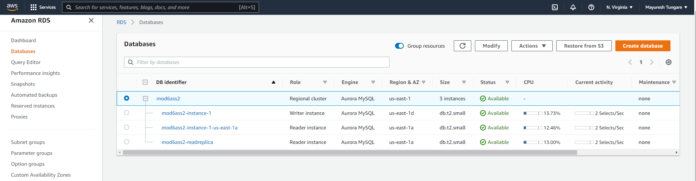

1. Thus, we have finally created Aurora database with 2 read replicas. Note one replica was created at the time of database creation. The other one was created afterwards.



1. Thus, this assignment is now complete.